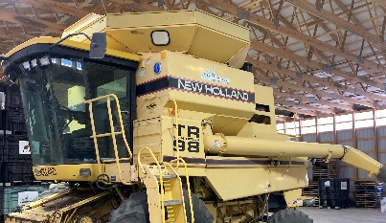  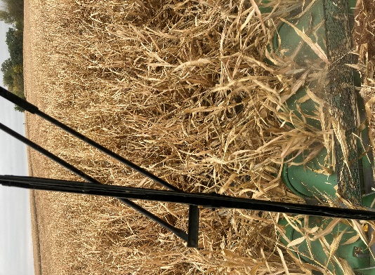

***“FROM THE SEAT OF THE TEST PLOT COMBINE”***

With another harvest in the books once again I would like to share some of my observations as I was combining through our test plots here at JLS.

First of all, here are a few overviews on some of our plots:

**Sanborn Plots- As most of you saw as you drove by Sanborn this year, we struggled with all the early rains. We tried our best as we harvested to get some information, however as you look over the data coming from the various plots at Sanborn keep in mind that the results might be slightly off at times.

**Hoffbeck Soybean Plot- The east part of this plot seemed to be at a disadvantage for some reason.

**Timm Soybean Plot- South side of this plot (the last few early varieties) always seem to have an advantage. We have seen the same thing over the years when we have a corn plot there.

**Larson Home NE Soybean Plot- The first few entries always have some hill to contend with that will hurt the yield slightly.

**Raddatz Corn Plot- The first 5 entries were in a very wet area on the south side.

Soybean Overview

***AG14XF4- I like this bean, it did well in plots & talking to customers it had a good year. It’s a bean you have to keep off your hottest IDC acres!

***AG16XF5- This bean will be new in 2025. It has extremely high yield with good IDC tolerance. It’s a slightly shorter plant. I really liked the yield on this variety in our plots. Definitely will replace 16XF3.

***AG17XF5- This soybean also has a nice yield advantage over our existing 1.7 bean (17XF2). Watch out placing this on higher PH acres however.

***AG19XF3- I like the consistency of this bean. It will be in its third year and is one of our top sellers. It also handles IDC acres well.

***AG20XF5- This NEW soybean performed well in plots. Put this on your non-IDC acres and you will be very happy with its top end yield!

***AG21XF0- This bean has been in our lineup since 2020. It’s very good on IDC and has been a big seller for us. Moving forward we have newer options that will show yield advantages.

***AG21XF2- Our top seller and when combining this in plots you always knew it would be one of our top performers. Just a great choice on any farm!

***AG23XF2- Great IDC bean that performed well in plots and is slightly earlier than its 2.3 maturity.

***AG24XF4- This was a new bean in 2024. It did very well in plots. One watchout would be on IDC acres. This variety appeared to be a little earlier than its 2.4 maturity.

***- Alloy- We were able to get a good look at our Alloy (Enlist) lineup in this year’s plots. We were able to place these beans in most plots. We have a full lineup from 1.2 maturity to 2.1. New for 2025 will be 14E35, 15E35, 18E35, & 20E35. I thought they performed very well! I think that our Asgrow lineup has a 1-3 Bu advantage, however if you like the Enlist program we have a very strong lineup w/many options!

Corn Observations

***DKC095-57- This second-year corn was very impressive in plots and seemed to be the corn to beat in this maturity. I liked this one!

***DKC096-21- Trecepta hybrid that arguably had a better showing in 2023 plots. This year it was a little behind 095-57 on yield.

***DKC098-88- The biggest takeaway here is VERY GOOD DRYDOWN! It truly resembles a 95 Day hybrid in maturity w/nice yields. Also, it’s a little shorter hybrid.

***DKC099-11- I liked this hybrid prior to plot combining last year in 2023, however it was consistently a little behind 098-88. However, in this year’s plots and in customers fields it had a very good year and was a leading hybrid in this maturity range.

***DKC101-33 &101-35- This corn is our top seller and for good reason. At 101 day it matches a maturity that will fit most operations and it just YIELDS! I have commented this fall that I think it’s the best corn in southern Minnesota!!

***DKC102-13 & 102-28- Both of these hybrids are very solid. I’ll give a slight moisture & yield advantage to 102-13(VT4PRO) in this year’s plots. They are nice compliments to 101-33 &101-35.

***DKC104-08- A very exciting NEW corn. I really liked this hybrid in plots this year. Actually, it’s one of my favorite hybrids in our lineup. When rolling through the plots I always knew it would be near the top! Everyone needs to look at this one when making plans for 2025!

***DKC104-14- This corn is also a NEW 104 Day (SSPRO). Unfortunately, we didn’t have any plot seed available at planting time so we will be looking outside our area for results on this one...

***DKC105-33 & 105-35- Another consistent year for this hybrid. It had another good year in plots and with our 104 & 106 Day around it we have some great choices in this maturity.

***DKC106-98- I was very impressed with this new 106 Day It has a very impressive yield and drydown and will definitely take some acres away from our older favorite 56-65.

***DKC57-45- Our dealership loves this hybrid. Its only negative is it’s a Double Pro. It had another strong performance year in plots and customers fields in 2024! It’s just a very high YIELDING corn!!

***DKC108-17- A new 108 day that has a very high, top end yield. It was our top yielder in a couple plots. The one negative in my eyes is it’s a very tall corn. That being said its maybe a hybrid to take a look at.

***DKC108-64- This hybrid was new in 2024 and did very well in plots and customers were very well pleased with performance! I think the corn will definitely move onto some 59-81 & 82 acres. Its better agronomically with comparable to yields and a fast dry down. I really like this corn.

***DKC59-81 & DKC59-82- We got another good look at this one and it had a nice year, but I think some of our new hybrids around this maturity might have more to offer going forward.

***DKC110-10- This 110 Day was the latest corn in some of our plots. We didn’t get a lot of info on this one. Again, it may be worth a look but I like our 106, 107, & 108 day hybrids so well that I would put my later acres in those hybrids.

***Pivot Bio- We got some data out of our plots with pivot. It did what we expected in our plots however some of our best data was with customers & split planters etc. Those were on bigger acreages and looked good. I like the product and if you want to try it out doing a split planter or partial fields it’s a really good way to get a look at it. With today’s yield monitors you can get some very accurate harvest information and you can judge for yourself if it’s something that works for you!

Thanks Again for reading my annual plot review and I hope it helps make your 2025 seed decision a little easier.

Jack